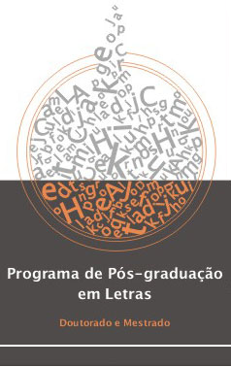

UNIVERSIDADE FEDERAL DE PERNAMBUCO

CENTRO DE ARTES E COMUNICAÇÃO

DEPARTAMENTO DE LETRAS

PROGRAMA DE PÓS-GRADUAÇÃO EM LETRAS
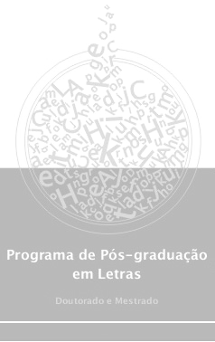
ATA DE EXAME DE QUALIFICAÇÃO

A Banca de Exame de Qualificação de Doutoramento composta pelos professores:
__________________________________________
__________________________________________
__________________________________________

Após argüição da(o) candidata(o) __________________________________ emitiu o seguinte parecer a respeito da Defesa do ________________________________________
________________________________________________________________________
_______________________________________________________________________:

__________________________________________________________________________
__________________________________________________________________________
__________________________________________________________________________
__________________________________________________________________________
__________________________________________________________________________
__________________________________________________________________________
__________________________________________________________________________
__________________________________________________________________________
__________________________________________________________________________
__________________________________________________________________________
Recife,______________________________________.

Assinaturas:
_________________________________________________________________
_________________________________________________________________
_________________________________________________________________

